Astanga Yoga Workshop with PHILIPPA ASHER

in OXFORD Friday 6th - Sunday 8th October 2017
Friday 6.30-8.30pm Counted primary class
Sat a.m. 11-1 Guided self-practice
Sat p.m. 2-4 Philosophy / concepts / technique workshop
Sun a.m. 10-12 Guided self-practice
Sun p.m. 1-3 Technique workshop (content for this class tbc)

VENUES: Friday & Saturday St Mary & St John Church Hall, 271 Cowley Rd, OX4 2AJ.Scarce street parking or use car park behind Tesco. Sunday: Summertown Church Hall, corner Banbury/Portland Rds, Oxford OX2 7EZ 200 yards north of Summertown’s M&S/ opp. BBC Oxford. Free street parking. Free tea/coffee & biscuits all w’end. Bring a mat or buy one at hall.
COST: £140 all weekend / £30 per session. Early bird discount: £125 / £27 if paid by Sat 30th September.
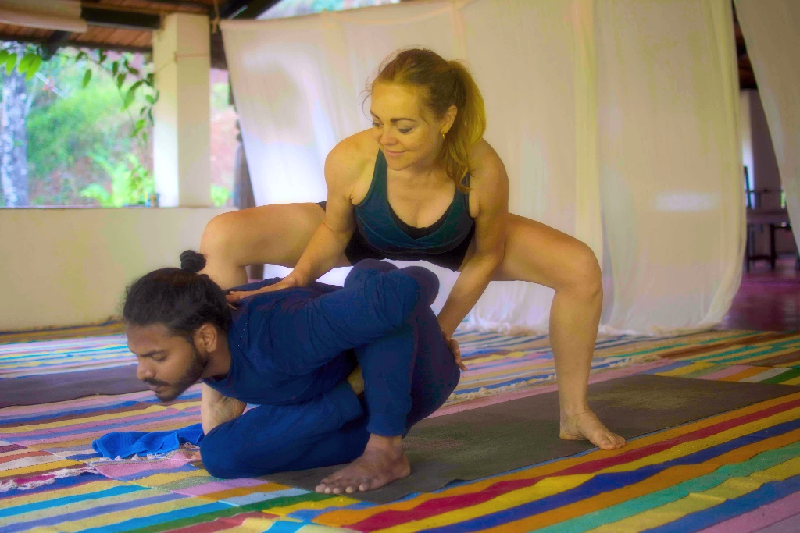
More photos at <signature-NEW-300x68.jpg> www.ashtangaphilippa.com

From London, Philippa Asher is one of a few Astanga yoga practitioners in the world (and the only British woman), to be Certified to teach the traditional Astanga yoga method, by Sri K Pattabhi Jois. She has learned the Primary, Intermediate, Advanced A and Advanced B Series directly from Guruji and Sharath (at the Krishna Pattabhi Jois Ashtanga Yoga Institute in Mysore, India) and shares the Astanga system, internationally.
After a vocational ballet school training from age twelve, and twenty five years of studying, and teaching dance at universities and ballet companies all over the UK, Philippa randomly walked into an Astanga yoga class in London. It was a life-changing incident that made complete sense.

From the late 1990s she began learning the Astanga system, daily before work (in the media, film and music industries). For over sixteen years she has studied for several months each year at KPJAYI in Mysore, practising under the guidance of Sri K Pattabhi Jois and his grandson Sharath Jois.

In 2006, Philippa established and ran Triyoga Soho’s Astanga self-practice programme in London. She taught there for five years before relocating to South India, to build her own shala (on a coffee estate in Sakleshpur, in the Western Ghats). ASHTANGA NIRVṚTA is a stunning homestay yoga retreat, which aims to bring Astanga yoga to all levels of practitioners, in nature.

As well as being the resident yoga teacher at ASHTANGA NIRVṚTA, Philippa also leads guest workshops at studios in India, Europe, London and on retreats worldwide. Her approach to sharing yoga asana (from beginners to more seasoned practitioners), is serious, yet light-hearted and joyful. Her emphasis is on good technique, safe alignment, synchronisation of tristhana (breath, gaze points and movement) and passing on the exact method, as taught by Guruji.

Philippa’s dedicated passion for Astanga yoga, background as a trained dancer and experience as a qualified teacher (Post Grad Certificate in the Education of Adults), gives her an intuitive and sound understanding of bodies, yoga asanas, people and how they learn.

Please enclose a stamped addressed envelope to receive an acknowledgement and send your booking form with a cheque or direct to NatWest a/c 08310483 I.Macdonald, sort code 54-21-23. If you do a transfer tell Ian at oxfordyoga@gmail.com 14 Chalfont Rd, Oxford OX2 6TH. 01865-421234 http://oxfordyoga.co.uk/wordpress/workshop-diary/
--------------------------------------------------------------------------------------------------------------------------------------------------------

Name(s)…………….…....……………….…….......……….…..……...email…….…………….…...……
.

Address ..………………………………………………………….…………………… Post Code .…...……
…..

I/we wish to attend the following classes (please appropriate box) on: Saturday a.m. Sat

p.m. SUNDAY a.m. Sunday p.m. and enclose a cheque for £……....., payable to Ian

Macdonald, with a stamped addressed envelope for a Receipt Philippa Asher, 2017 21 Sep

